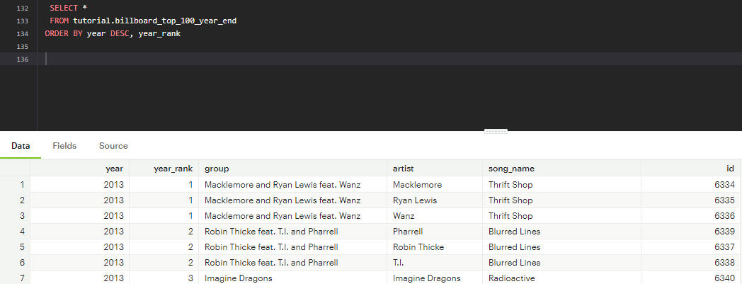

- In this query by using ORDER BY with the year DESC we are able to see the most recently ranked album.

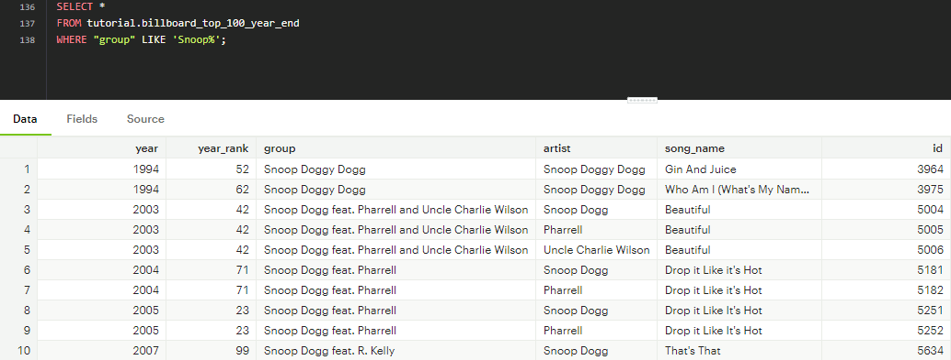

- The LIKE operator is used in this query to see which rows under “group” starts with “Snoop”. Wildcard “%” is used to represent any character that comes after. We observe Snoop Doggy Dogg, Snoop Dogg, etc.

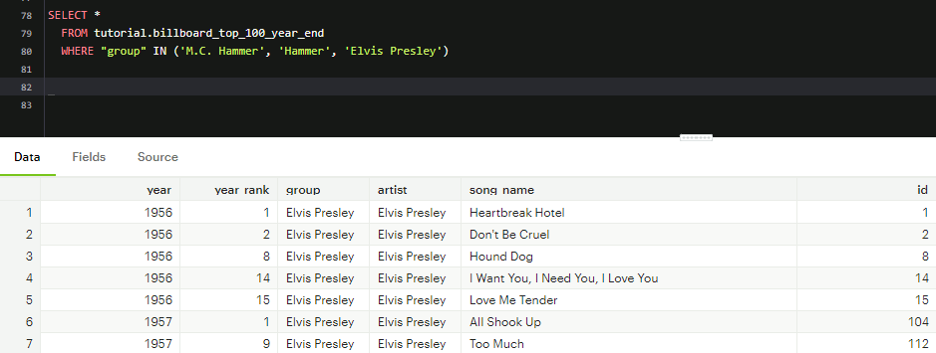

- This query shows all of the entries for elvis and M.C Hammer. MC hammer is listed in multiple names so we have to write both ways.

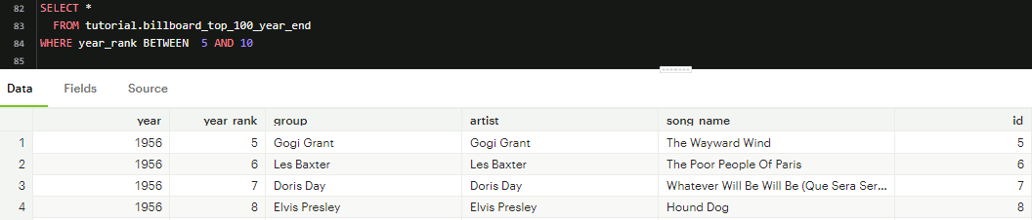

- Using logical operator to select only rows that are within a specific range

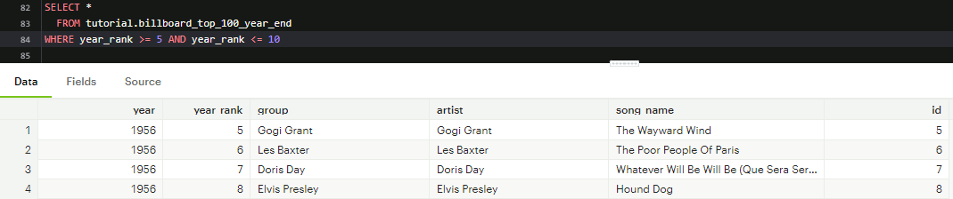

- Using the = specification will return the exact results

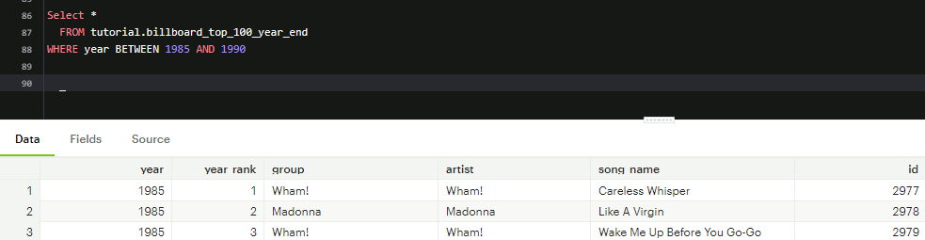

- This query shows all the top 100 songs from Jan 1,1985 through Dec 31,1990

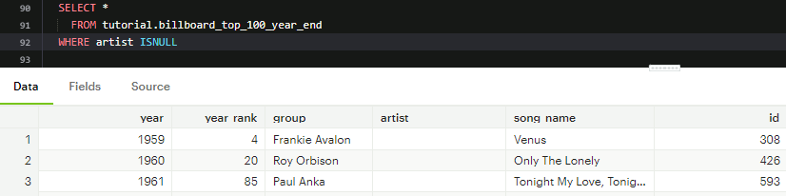

- An ISNULL statement is run to check all of the values where Artist is NULL or blank.

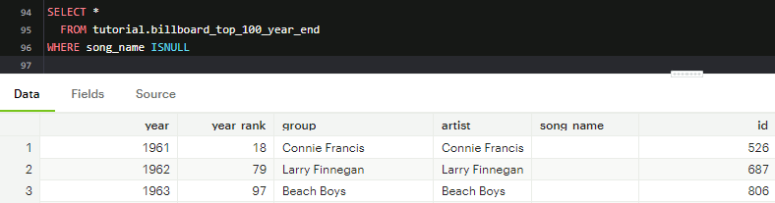

- This query shows all of the rows of which song_name is null

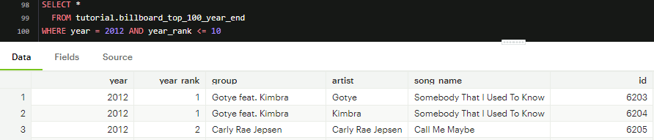

- This query will return all rows for top-10 recordings in 2012. We use the where clause and the AND clause

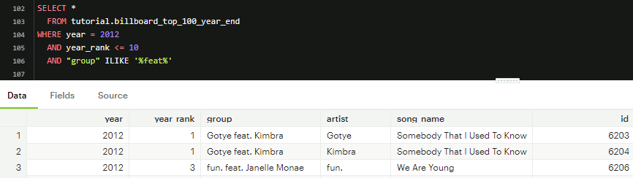

- In this query, we are pulling data from the year 2012, where the rank is less than 10 and is grouped by featured music.

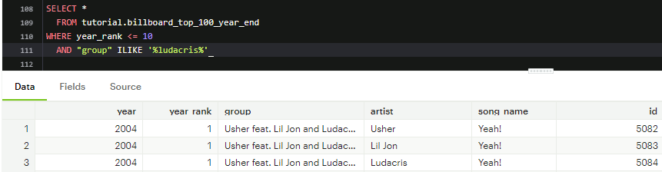

- This query surfaces all rows for top-10 hits for which Ludacris is part of the group

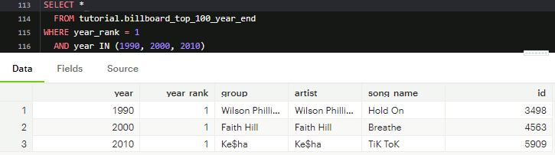

- This query surfaces the top-ranked records in 1990, 2000, 2010

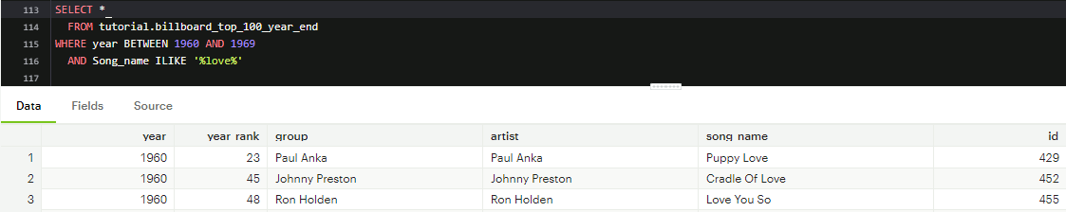

- This query lists all songs from the 1960s with ‘Love’ in the title

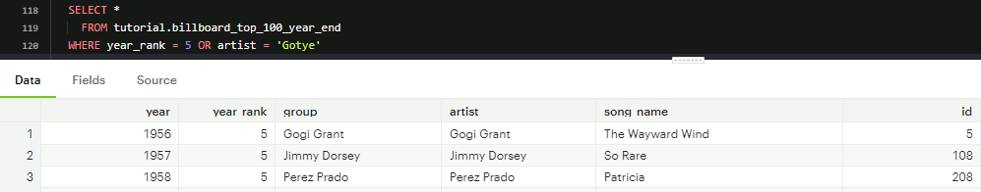

- OR logical operator is used to satisfy either of the two conditions, it is similar to AND but and condition has to satisfy both of the two conditions versus OR has to do either one.

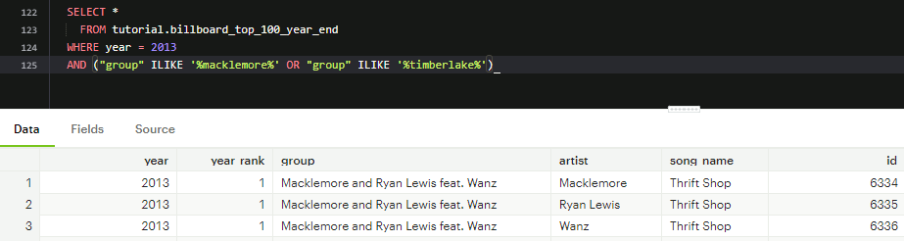

- Year is 2013 and the group column is made of like values of macklemore or timberlake

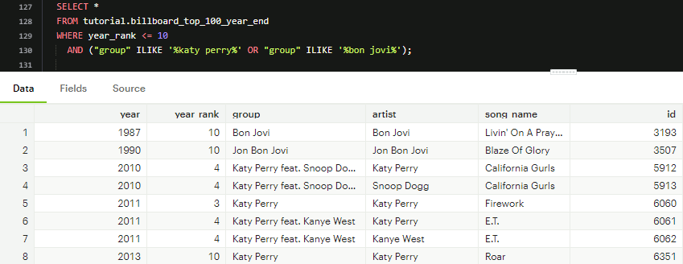

- The purpose of this query is that it returns all rows for top-10 songs that featured either Katy Perry or Bon Jovi. Group is used to create a column for the two artist to show in. ILIKE is used to populate any Katy Perry and Bon Jovi music with features. Or is used because we want either OR.

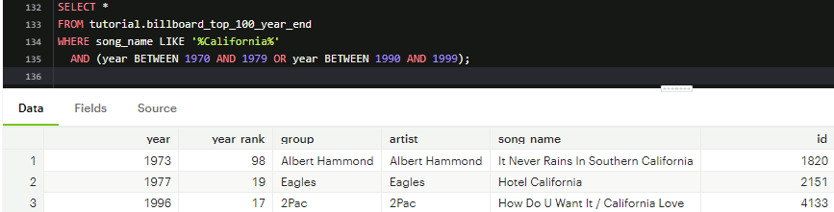

- This query returns all songs with titles that contain the word “California” in either the 1970s or 1990s. Song_name is used with LIKE ‘%California%’ to find like song name. Then we use the AND clause with Between and OR because we want to find the song names between 1970-1979 and 1990-1999.

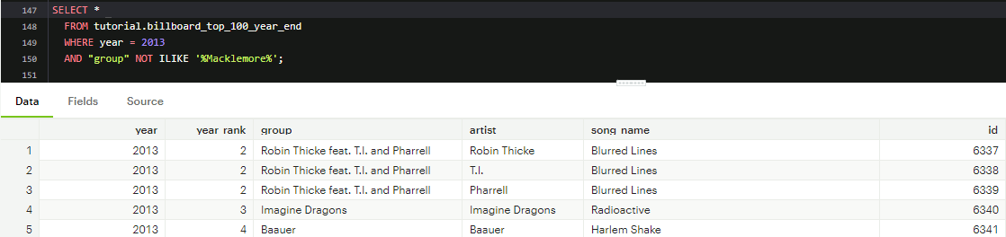

- In this query, we explore the NOT logical operator, we are looking at the group where names of Macklemore are not in them.

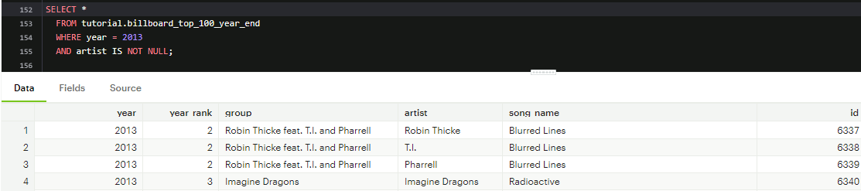

- This query, I explore the NOT operator but when looking to identify non-null rows, IS needs to be used beforehand as observed.

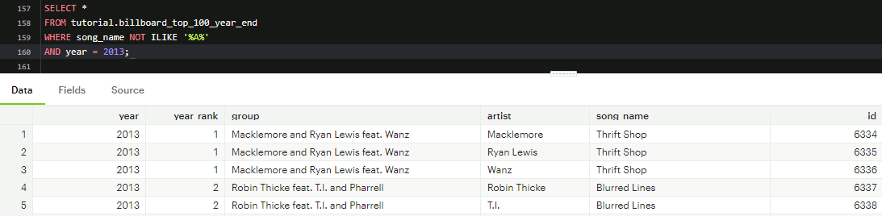

- Here we explore all the rows for songs that were on the charts in 2013 and do not contain the letter “a”.

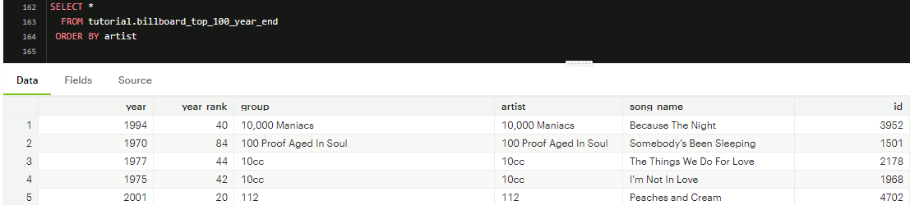

- The ORDER BY clause is used to reorder the results based on the data in one or more columns. In this instance, we are using ORDER BY Artist and it is “alphabetically ordering from A-Z or Ascending Order which is default in SQL.

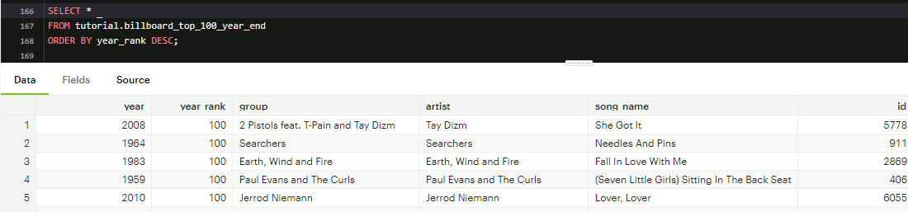

- Here we use the ORDER BY clause with year_rank and in DESC ordering. What this does is it shows us to Higher or top ranking first. Since our table is called top 100 year end, we see the top 100 shows first.

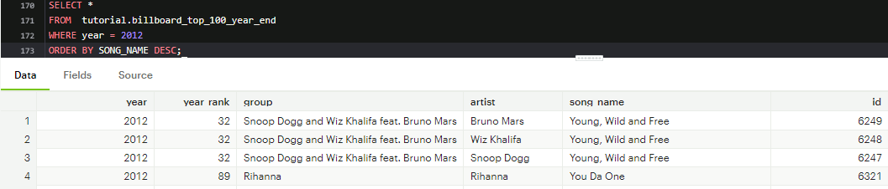

- This query returns all rows from 2012, ordered by song title and from DESC Z-A order.

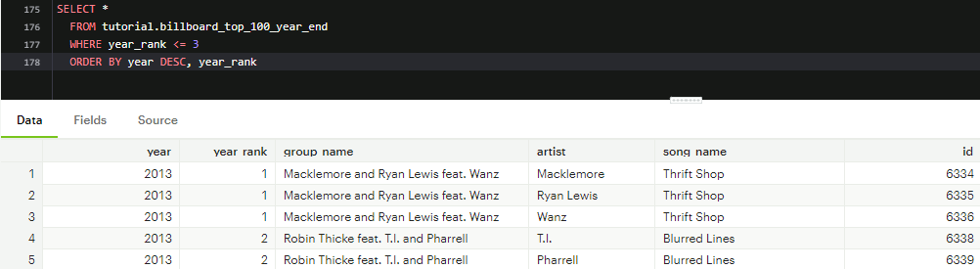

- Ordering data by multiple columns. This is helpful when data is in multiple categories. In this example we are organizing by date in the most recent years first and ordering the top rank songs over the lower ranked songs

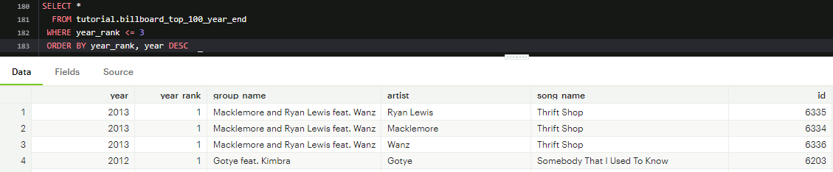

- This query is similar to the above query but this displays that the order makes a difference on the data pulled. Here we see the year rank is first then the year in descending order comes after.

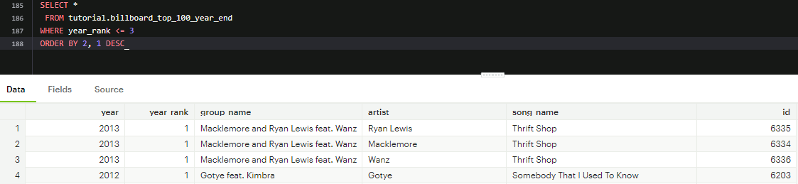

- Using numbers to substitute the column names to make the query look cleaner

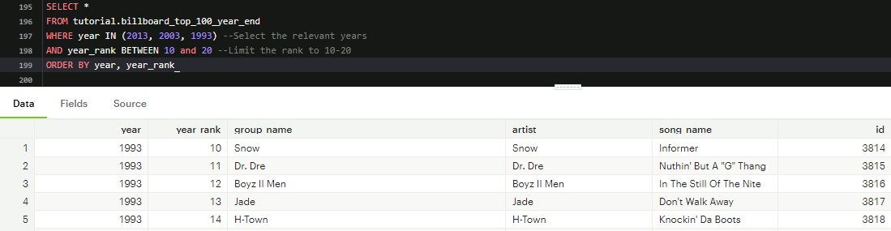

- This query returns songs that ranked between 10 and 20 (inclusive) in 1993, 2003, or 2013. The results are ordered by year and rank. Looking at the results we see year 1993 is shown first and the year rank for the song is shown as well.

CODE

SELECT * FROM tutorial.billboard_top_100_year_end

SELECT *

FROM tutorial.billboard_top_100_year_end

ORDER BY year DESC, year_rank

SELECT *

FROM tutorial.billboard_top_100_year_end

WHERE "group" LIKE 'Snoop%';

SELECT *

FROM tutorial.billboard_top_100_year_end

WHERE artist ILIKE 'dr_ke'

SELECT *

FROM tutorial.billboard_top_100_year_end

WHERE "group" ilike '%ludacris%'

SELECT *

FROM tutorial.billboard_top_100_year_end

WHERE "group" LIKE 'DJ%'

SELECT *

FROM tutorial.billboard_top_100_year_end

WHERE year_rank IN (1, 2, 3)

SELECT *

FROM tutorial.billboard_top_100_year_end

WHERE artist IN ('Taylor Swift', 'Usher', 'Ludacris')

SELECT *

FROM tutorial.billboard_top_100_year_end

WHERE "group" IN ('M.C. Hammer', 'Hammer', 'Elvis Presley')

SELECT *

FROM tutorial.billboard_top_100_year_end

WHERE year_rank BETWEEN 5 AND 10

SELECT *

FROM tutorial.billboard_top_100_year_end

WHERE year_rank >= 5 AND year_rank <= 10

SELECT *

FROM tutorial.billboard_top_100_year_end

WHERE year BETWEEN 1985 AND 1990

SELECT *

FROM tutorial.billboard_top_100_year_end

WHERE artist IS NULL

SELECT *

FROM tutorial.billboard_top_100_year_end

WHERE song_name IS NULL

SELECT *

FROM tutorial.billboard_top_100_year_end

WHERE year = 2012 AND year_rank <= 10

SELECT *

FROM tutorial.billboard_top_100_year_end

WHERE year = 2012

AND year_rank <= 10

AND "group" ILIKE '%feat%'

SELECT *

FROM tutorial.billboard_top_100_year_end

WHERE year_rank <= 10

AND "group" ILIKE '%ludacris%'

SELECT *

FROM tutorial.billboard_top_100_year_end

WHERE year_rank IN (1, 2, 3)

SELECT *

FROM tutorial.billboard_top_100_year_end

WHERE artist IN ('Taylor Swift', 'Usher', 'Ludcaris')

SELECT *

FROM tutorial.billboard_top_100_year_end

WHERE "group" IN ('M.C. Hammer', 'Hammer', 'Elvis Presley')

SELECT *

FROM tutorial.billboard_top_100_year_end

WHERE year_rank >= 5 AND year_rank <= 10

Select *

FROM tutorial.billboard_top_100_year_end

WHERE year BETWEEN 1985 AND 1990

SELECT *

FROM tutorial.billboard_top_100_year_end

WHERE artist ISNULL

SELECT *

FROM tutorial.billboard_top_100_year_end

WHERE song_name ISNULL

SELECT *

FROM tutorial.billboard_top_100_year_end

WHERE year = 2012 AND year_rank <= 10

SELECT *

FROM tutorial.billboard_top_100_year_end

WHERE year = 2012

AND year_rank <= 10

AND "group" ILIKE '%feat%'

SELECT *

FROM tutorial.billboard_top_100_year_end

WHERE year_rank <= 10

AND "group" ILIKE '%ludacris%'

SELECT *

FROM tutorial.billboard_top_100_year_end

WHERE year BETWEEN 1960 AND 1969

AND Song_name ILIKE '%love%'

SELECT *

FROM tutorial.billboard_top_100_year_end

WHERE year_rank = 5 OR artist = 'Gotye'

SELECT *

FROM tutorial.billboard_top_100_year_end

WHERE year = 2013

AND ("group" ILIKE '%macklemore%' OR "group" ILIKE '%timberlake%')

SELECT *

FROM tutorial.billboard_top_100_year_end

WHERE year_rank <= 10

AND ("group" ILIKE '%katy perry%' OR "group" ILIKE '%bon jovi%');

SELECT *

FROM tutorial.billboard_top_100_year_end

WHERE song_name LIKE '%California%'

AND (year BETWEEN 1970 AND 1979 OR year BETWEEN 1990 AND 1999);

SELECT *

FROM tutorial.billboard_top_100_year_end

WHERE "group" ILIKE '%dr. dre%'

AND (year <= 2000 OR year >= 2010)

SELECT *

FROM tutorial.billboard_top_100_year_end

WHERE year = 2013

AND year_rank NOT BETWEEN 2 AND 3

SELECT *

FROM tutorial.billboard_top_100_year_end

WHERE year = 2013

AND "group" NOT ILIKE '%Macklemore%';

SELECT *

FROM tutorial.billboard_top_100_year_end

WHERE year = 2013

AND artist IS NOT NULL;

SELECT *

FROM tutorial.billboard_top_100_year_end

WHERE song_name NOT ILIKE '%A%'

AND year = 2013;

SELECT *

FROM tutorial.billboard_top_100_year_end

ORDER BY artist

SELECT *

FROM tutorial.billboard_top_100_year_end

ORDER BY year_rank DESC;

SELECT *

FROM tutorial.billboard_top_100_year_end

WHERE year = 2012

ORDER BY SONG_NAME DESC;

SELECT *

FROM tutorial.billboard_top_100_year_end

WHERE year_rank <= 3

ORDER BY year DESC, year_rank

SELECT *

FROM tutorial.billboard_top_100_year_end

WHERE year_rank <= 3

ORDER BY year_rank, year DESC

SELECT *

FROM tutorial.billboard_top_100_year_end

WHERE year_rank <= 3

ORDER BY 2, 1 DESC

SELECT *

FROM tutorial.billboard_top_100_year_end

WHERE year = 2010

ORDER BY year_rank, artist

SELECT *

FROM tutorial.billboard_top_100_year_end

WHERE year IN (2013, 2003, 1993) --Select the relevant years

AND year_rank BETWEEN 10 and 20 --Limit the rank to 10-20

ORDER BY year, year_rank